**Creating Fully Responsive Website Project Using HTML & CSS in Hindi | Web Development Tutorials #39**

In this tutorial, we are going to create a fully responsive website from scratch with the help of HTML and CSS. The website we will create will be somewhat similar to food delivery services. The website will automatically behave responsively according to different screen sizes as shown below-

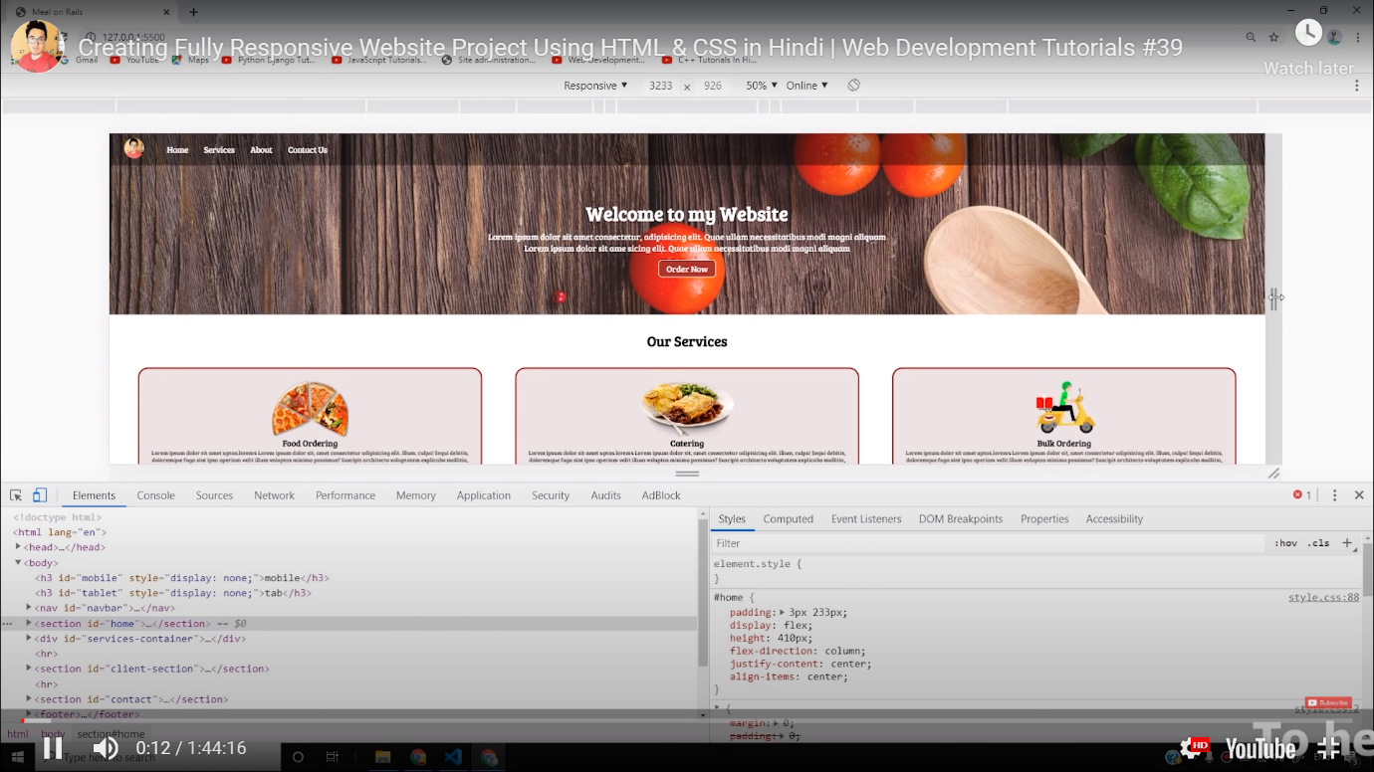

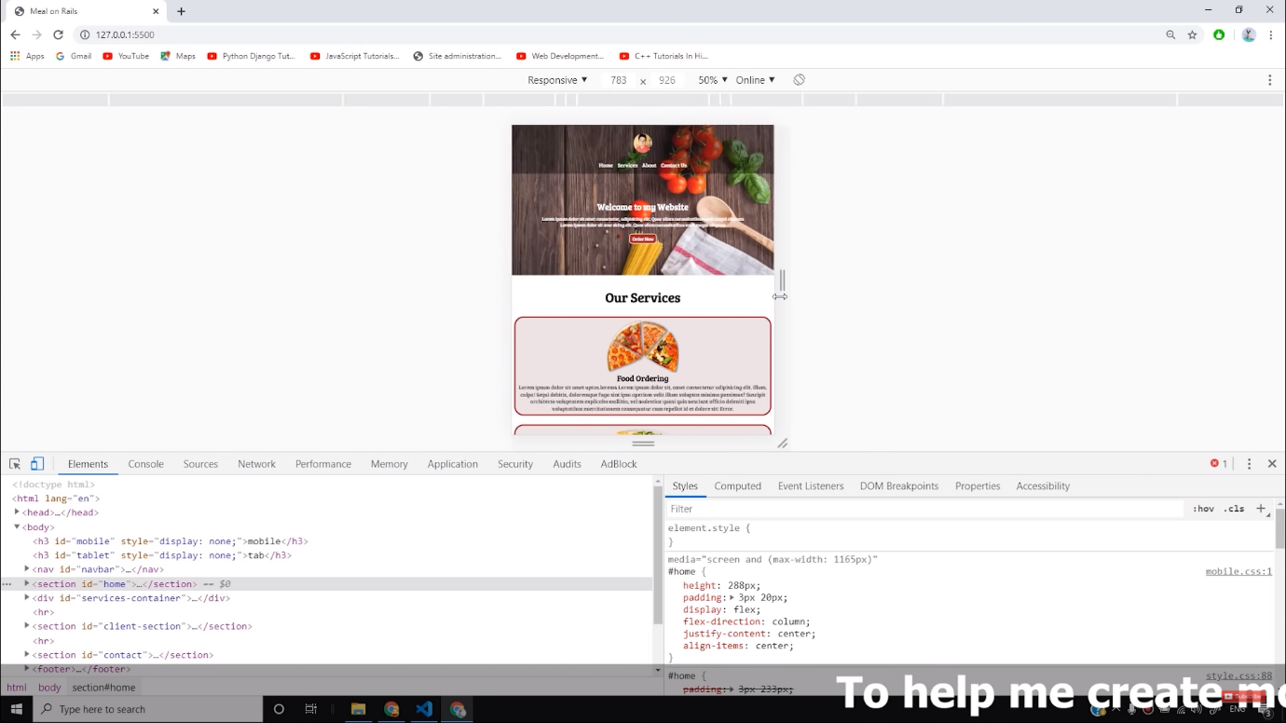

Before starting, take a look at all the folders, we will use. Download all the images from copyright-free sources and arrange them according to different folders.

Make a new file as *index.html*and add the boilerplate. Then give the title as the **Best Online Food Delivery Services in India | MyOnlineMeal.com** under the <title> tag.

We will begin by making a navbar and give it an **id** as follows-

<nav id="navbar">

<div id="logo">

<img src="logo.png" alt="MyOnlineMeal.com">

</div>

<ul>

<li class="item"><a href="#home">Home</a></li>

<li class="item"><a href="#services-container">Services</a></li>

<li class="item"><a href="#client-section">Our Clients</a></li>

<li class="item"><a href="#contact">Contact Us</a></li>

</ul>

</nav>

Copy

In the above code, we have created a navbar and attached an image to it. We have then added several **li’s**to it like about us, contact us, etc. headings. The next step is to apply CSS to the navbar, logo, and list items. After applying it, the final result will look like as follows-

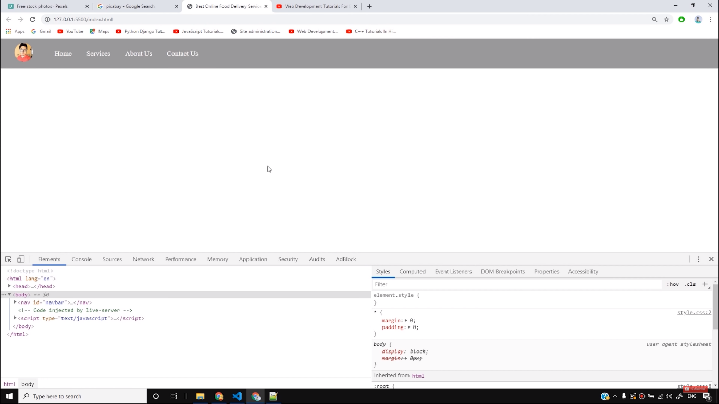

Now we will make a section below it and add a background image to it. Create a section with id as **home**as follows-

<section id="home">

<h1 class="h-primary">Welcome to MyOnlineMeal</h1>

<p>Lorem ipsum dolor sit amet consectetur, adipisicing elit. Perferendis dolorum numquam minus. </p>

<p>Lorem ipsum dolor sit amet consectetur, adipisicing elit. </p>

<button class="btn">Order Now</button>

</section>

Copy

The next step is to customize this section with the CSS. We will target each element of the home section and customize them individually. After adding the CSS, the result will look as follows-

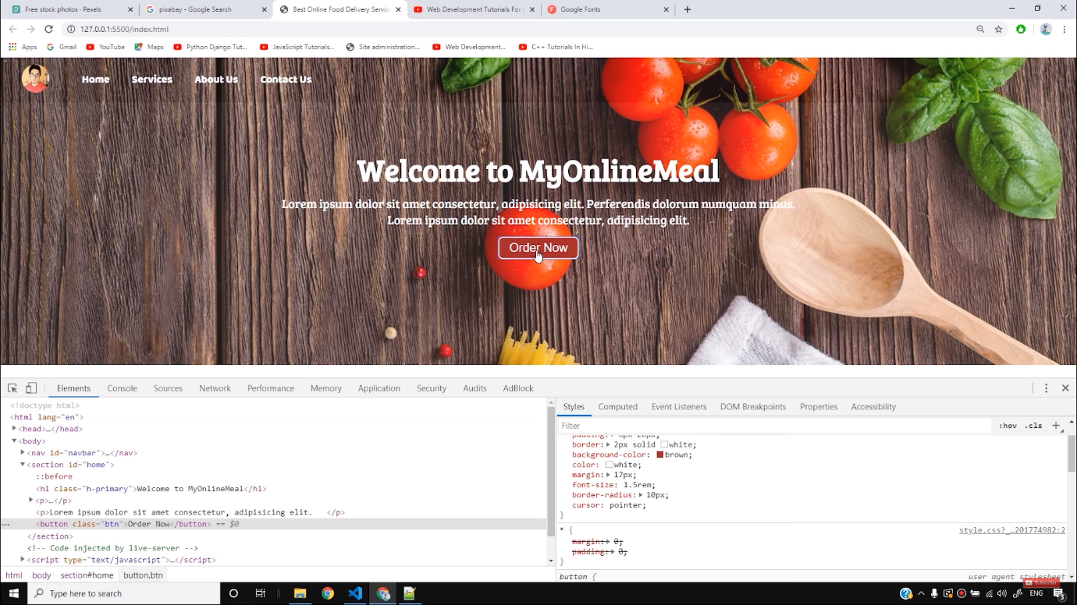

Next, we will make the services class where we will describe the services provided by us. The code is as follows-

<section id="services-container">

<h1 class="h-primary center">Our Services</h1>

<div id="services">

<div class="box">

<img src="img/1.png" alt="">

<h2 class="h-secondary center">Food Catering</h2>

<p class="center">Lorem ipsum dolor sit, amet consectetur adipisicing elit. Quidem, culpa suscipit error

Lorem ipsum dolor sit, amet consectetur adipisicing elit. Et qui, repudiandae similique nam, recusandae quidem ab asperiores ex, aut fugit labore veritatis facere?

sint delectus ab dolorum nam. Debitis facere, incidunt voluptates eos, mollitia voluptatem iste sunt

voluptas beatae facilis labore, omnis sint quae eum.</p>

</div>

<div class="box">

<img src="img/2.png" alt="">

<h2 class="h-secondary center">Bulk Ordering</h2>

<p class="center">Lorem ipsum dolor sit, amet consectetur adipisicing elit. Quidem, culpa suscipit error

Lorem ipsum dolor sit amet consectetur adipisicing elit. Unde laudantium a incidunt animi ad, ab dignissimos vero? Unde numquam odit repudiandae perferendis nisi.

sint delectus ab dolorum nam. Debitis facere, incidunt voluptates eos, mollitia voluptatem iste sunt

voluptas beatae facilis labore, omnis sint quae eum.</p>

</div>

<div class="box">

<img src="img/3.png" alt="">

<h2 class="h-secondary center">Food Ordering</h2>

<p class="center">Lorem ipsum dolor sit, amet consectetur adipisicing elit. Quidem, culpa suscipit error

Lorem ipsum dolor sit amet consectetur adipisicing elit. Necessitatibus provident fugiat aliquam minima at explicabo. Earum eveniet quaerat, sunt molestias nesciunt quas! Quis.

sint delectus ab dolorum nam. Debitis facere, incidunt voluptates eos, mollitia voluptatem iste sunt

voluptas beatae facilis labore, omnis sint quae eum.</p>

</div>

</div>

</section>

Copy

Now we will add CSS to this **services container section** and modify it accordingly. After modifying the **box** and **images**in the services section, the result will look as follows-

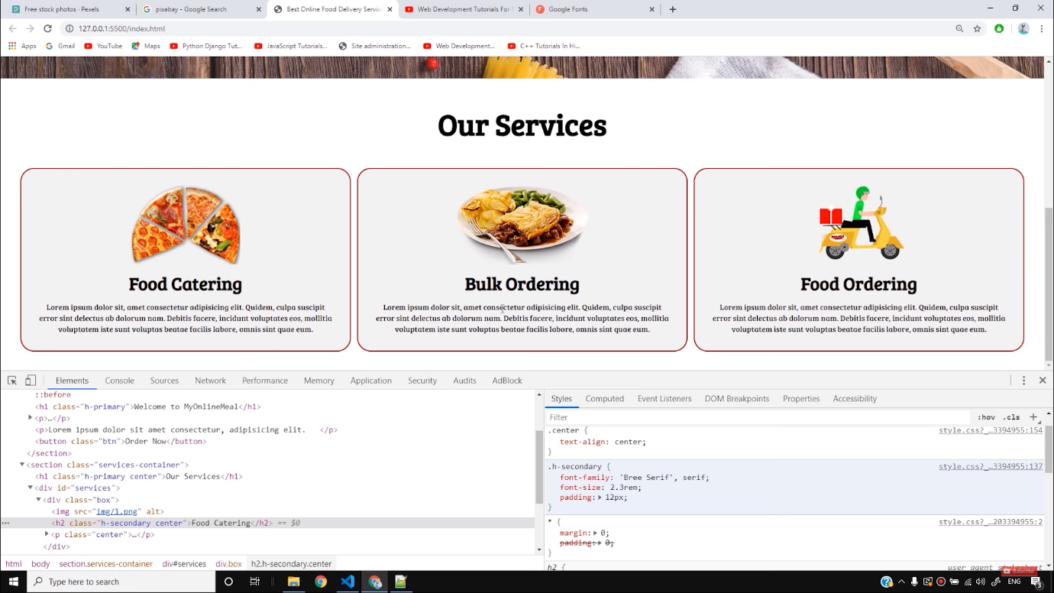

The next step is to add the client's section on the page or the sensors of our page. Here we can name our clients and add a picture of them. The code for it is as follows-

<section id="client-section">

<h1 class="h-primary center">Our Clients</h1>

<div id="clients">

<div class="client-item">

<img src="img/logo1.png" alt="Our Client">

</div>

<div class="client-item">

<img src="img/logo2.png" alt="Our Client">

</div>

<div class="client-item">

<img src="img/logo4.png" alt="Our Client">

</div>

<div class="client-item">

<img src="img/logo3.png" alt="Our Client">

</div>

</div>

</section>

Copy

Now we will add CSS to this section and the first step is to convert the section after **our clients** should be converted into a flexbox. After applying all the CSS to this section, the result will look as follows-

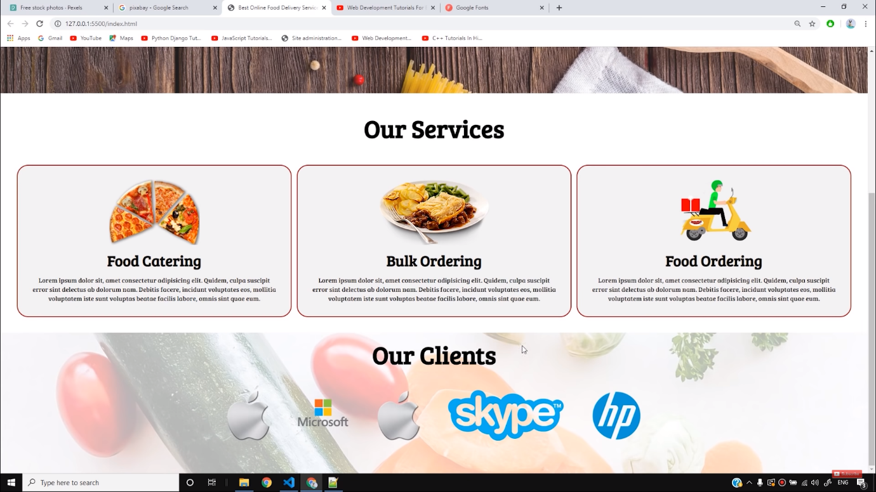

Next, we will add the contact form to our website. The form will contain a *name, email, phone no.,*and *message box.* The code for it is as follows-

<section id="contact">

<h1 class="h-primary center">Contact Us</h1>

<div id="contact-box">

<form action="">

<div class="form-group">

<label for="name">Name: </label>

<input type="text" name="name" id="name" placeholder="Enter your name">

</div>

<div class="form-group">

<label for="email">Email: </label>

<input type="email" name="name" id="email" placeholder="Enter your email">

</div>

<div class="form-group">

<label for="phone">Phone Number: </label>

<input type="phone" name="name" id="phone" placeholder="Enter your phone">

</div>

<div class="form-group">

<label for="message">Message: </label>

<textarea name="message" id="message" cols="30" rows="10"></textarea>

</div>

</form>

</div>

</section>

Copy

The next step is to style our form with the help of CSS. We will differently style *contact::before, contact-box, contact-box input, contact-box form,*and *contact-box label.*After doing all the necessary changes, the form will look as follows-

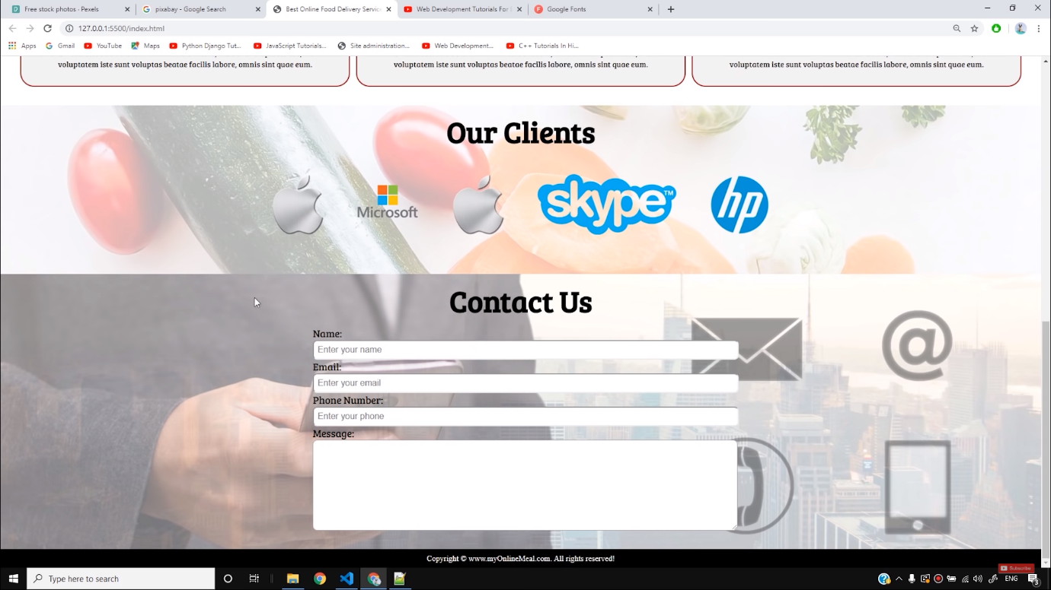

The next step is to make the website responsive. For making it responsive, we will make a new file as *phone.css* and necessary code here. Add the file in the HTML along with media queries as follows-

<link rel="stylesheet" media="screen and (max-width: 1170px)" href="css/phone.css">

Copy

After doing all the necessary changes to make the website responsive, the result will look as follows-

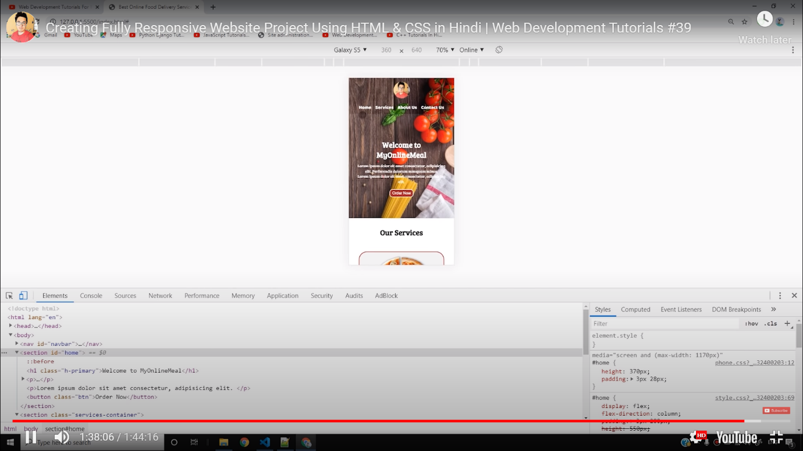

So I hope you must have got an idea of how to make a fully responsive website using HTML and CSS. Try to customize more things according to your needs and keep practicing.

[Click here to download this project as a zip file](https://api.codewithharry.com/media/videoSeriesFiles/courseFiles/web-development-in-hindi-39/Project-2.zip)

Download the complete source code from the description section. I have uploaded it as a zip file!

Copy

**Code file .\index.html as described in the video**

<!DOCTYPE html>

<html lang="en">

<head>

<meta charset="UTF-8">

<meta name="viewport" content="width=device-width, initial-scale=1.0">

<meta http-equiv="X-UA-Compatible" content="ie=edge">

<title>Best Online Food Delivery Service in India | MyOnlineMeal.com</title>

<link rel="stylesheet" href="css/style.css">

<link rel="stylesheet" media="screen and (max-width: 1170px)" href="css/phone.css">

<link href="https://fonts.googleapis.com/css?family=Baloo+Bhai|Bree+Serif&display=swap" rel="stylesheet">

</head>

<body>

<nav id="navbar">

<div id="logo">

<img src="logo.png" alt="MyOnlineMeal.com">

</div>

<ul>

<li class="item"><a href="#home">Home</a></li>

<li class="item"><a href="#services-container">Services</a></li>

<li class="item"><a href="#client-section">Our Clients</a></li>

<li class="item"><a href="#contact">Contact Us</a></li>

</ul>

</nav>

<section id="home">

<h1 class="h-primary">Welcome to MyOnlineMeal</h1>

<p>Lorem ipsum dolor sit amet consectetur, adipisicing elit. Perferendis dolorum numquam minus. </p>

<p>Lorem ipsum dolor sit amet consectetur, adipisicing elit. </p>

<button class="btn">Order Now</button>

</section>

<section id="services-container">

<h1 class="h-primary center">Our Services</h1>

<div id="services">

<div class="box">

<img src="img/1.png" alt="">

<h2 class="h-secondary center">Food Catering</h2>

<p class="center">Lorem ipsum dolor sit, amet consectetur adipisicing elit. Quidem, culpa suscipit error

Lorem ipsum dolor sit, amet consectetur adipisicing elit. Et qui, repudiandae similique nam, recusandae quidem ab asperiores ex, aut fugit labore veritatis facere?

sint delectus ab dolorum nam. Debitis facere, incidunt voluptates eos, mollitia voluptatem iste sunt

voluptas beatae facilis labore, omnis sint quae eum.</p>

</div>

<div class="box">

<img src="img/2.png" alt="">

<h2 class="h-secondary center">Bulk Ordering</h2>

<p class="center">Lorem ipsum dolor sit, amet consectetur adipisicing elit. Quidem, culpa suscipit error

Lorem ipsum dolor sit amet consectetur adipisicing elit. Unde laudantium a incidunt animi ad, ab dignissimos vero? Unde numquam odit repudiandae perferendis nisi.

sint delectus ab dolorum nam. Debitis facere, incidunt voluptates eos, mollitia voluptatem iste sunt

voluptas beatae facilis labore, omnis sint quae eum.</p>

</div>

<div class="box">

<img src="img/3.png" alt="">

<h2 class="h-secondary center">Food Ordering</h2>

<p class="center">Lorem ipsum dolor sit, amet consectetur adipisicing elit. Quidem, culpa suscipit error

Lorem ipsum dolor sit amet consectetur adipisicing elit. Necessitatibus provident fugiat aliquam minima at explicabo. Earum eveniet quaerat, sunt molestias nesciunt quas! Quis.

sint delectus ab dolorum nam. Debitis facere, incidunt voluptates eos, mollitia voluptatem iste sunt

voluptas beatae facilis labore, omnis sint quae eum.</p>

</div>

</div>

</section>

<section id="client-section">

<h1 class="h-primary center">Our Clients</h1>

<div id="clients">

<div class="client-item">

<img src="img/logo1.png" alt="Our Client">

</div>

<div class="client-item">

<img src="img/logo2.png" alt="Our Client">

</div>

<div class="client-item">

<img src="img/logo4.png" alt="Our Client">

</div>

<div class="client-item">

<img src="img/logo3.png" alt="Our Client">

</div>

</div>

</section>

<section id="contact">

<h1 class="h-primary center">Contact Us</h1>

<div id="contact-box">

<form action="">

<div class="form-group">

<label for="name">Name: </label>

<input type="text" name="name" id="name" placeholder="Enter your name">

</div>

<div class="form-group">

<label for="email">Email: </label>

<input type="email" name="name" id="email" placeholder="Enter your email">

</div>

<div class="form-group">

<label for="phone">Phone Number: </label>

<input type="phone" name="name" id="phone" placeholder="Enter your phone">

</div>

<div class="form-group">

<label for="message">Message: </label>

<textarea name="message" id="message" cols="30" rows="10"></textarea>

</div>

</form>

</div>

</section>

<footer>

<div class="center">

Copyright &copy; www.myOnlineMeal.com. All rights reserved!

</div>

</footer>

</body>

</html>

Copy

**Code file phone.css as described in the video**

/* Navigation */

#navbar {

flex-direction: column;

}

#navbar ul li a{

font-size: 1rem;

padding: 0px 7px;

padding-bottom: 8px;

}

/* Home section */

#home{

height: 370px;

padding: 3px 28px;

}

#home::before{

height: 480px;

}

#home p{

font-size: 13px;

}

/* Services section */

#services{

flex-direction: column;

}

#services .box {

padding: 14px;

margin: 2px 0px;

margin-bottom: 20px;

}

/* Clients section */

#clients{

flex-wrap: wrap;

}

#clients img{

width: 66px;

padding: 6px;

height: auto;

}

/* Contact us section */

#contact-box form{

width:80%;

}

/* Footer */

/* Utility classes */

.h-primary{

font-size:26px;

}

.btn{

font-size: 13px;

padding: 4px 8px;

}

Copy

**Code file style.css as described in the video**

/* CSS Reset */

*{

margin: 0;

padding: 0;

}

html{

scroll-behavior: smooth;

}

/* CSS Variables */

:root{

--navbar-height: 59px;

}

/* Navigation Bar */

#navbar{

display: flex;

align-items: center;

position: sticky;

top: 0px;

}

#navbar::before{

content: "";

background-color: black;

position: absolute;

top:0px;

left:0px;

height: 100%;

width:100%;

z-index: -1;

opacity: 0.7;

}

/* Navigation Bar: Logo and Image */

#logo{

margin: 10px 34px;

}

#logo img{

height: 59px;

margin: 3px 6px;

}

/* Navigation Bar: List Styling */

#navbar ul{

display: flex;

font-family: 'Baloo Bhai', cursive;

}

#navbar ul li{

list-style: none;

font-size: 1.3rem;

}

#navbar ul li a{

color: white;

display: block;

padding: 3px 22px;

border-radius: 20px;

text-decoration: none;

}

#navbar ul li a:hover{

color: black;

background-color: white;

}

/* Home Section */

#home{

display: flex;

flex-direction: column;

padding:3px 200px;

height: 550px;

justify-content: center;

align-items: center;

}

#home::before{

content: "";

position: absolute;

background: url('../bg1.jpg') no-repeat center center/cover;

height: 642px;

top:0px;

left:0px;

width: 100%;

z-index: -1;

opacity:0.89;

}

#home h1{

color:white;

text-align: center;

font-family: 'Bree Serif', serif;

}

#home p{

color:white;

text-align: center;

font-size: 1.5rem;

font-family: 'Bree Serif', serif;

}

/* Services Section */

#services{

margin: 34px;

display: flex;

}

#services .box{

border: 2px solid brown;

padding: 34px;

margin: 2px 55px;

border-radius: 28px;

background: #f2f2f2;

margin-bottom: 20px;

}

#services .box img{

height: 160px;

margin: auto;

display: block;

}

#services .box p{

font-family: 'Bree Serif', serif;

}

/* Clients Section */

#client-section{

position: relative;

}

#client-section::before{

content: "";

position: absolute;

background: url('../bg.jpg');

width: 100%;

height: 100%;

z-index: -1;

opacity: 0.3;

}

#clients{

display: flex;

justify-content: center;

align-items: center;

}

.client-item{

padding: 34px;

}

#clients img{

height: 124px;

}

/* Contact Section */

#contact{

position: relative;

}

#contact::before{

content: "";

position: absolute;

width: 100%;

height: 100%;

z-index: -1;

opacity: 0.7;

background: url('../contact.jpg') no-repeat center center/cover;

}

#contact-box{

display: flex;

justify-content: center;

align-items: center;

padding-bottom: 34px;

}

#contact-box input,

#contact-box textarea{

width: 100%;

padding: 0.5rem;

border-radius: 9px;

font-size: 1.1rem;

}

#contact-box form{

width: 40%;

}

#contact-box label{

font-size: 1.3rem;

font-family: 'Bree Serif', serif;

}

footer{

background: black;

color: white;

padding: 9px 20px;

}

/* Utility Classes */

.h-primary{

font-family: 'Bree Serif', serif;

font-size: 3.8rem;

padding: 12px;

}

.h-secondary{

font-family: 'Bree Serif', serif;

font-size: 2.3rem;

padding: 12px;

}

.btn{

padding: 6px 20px;

border: 2px solid white;

background-color: brown;

color: white;

margin: 17px;

font-size: 1.5rem;

border-radius: 10px;

cursor:pointer;

}

.center{

text-align: center;

}